GRAPHICS ACTIVITY

EDITING

BEFORE

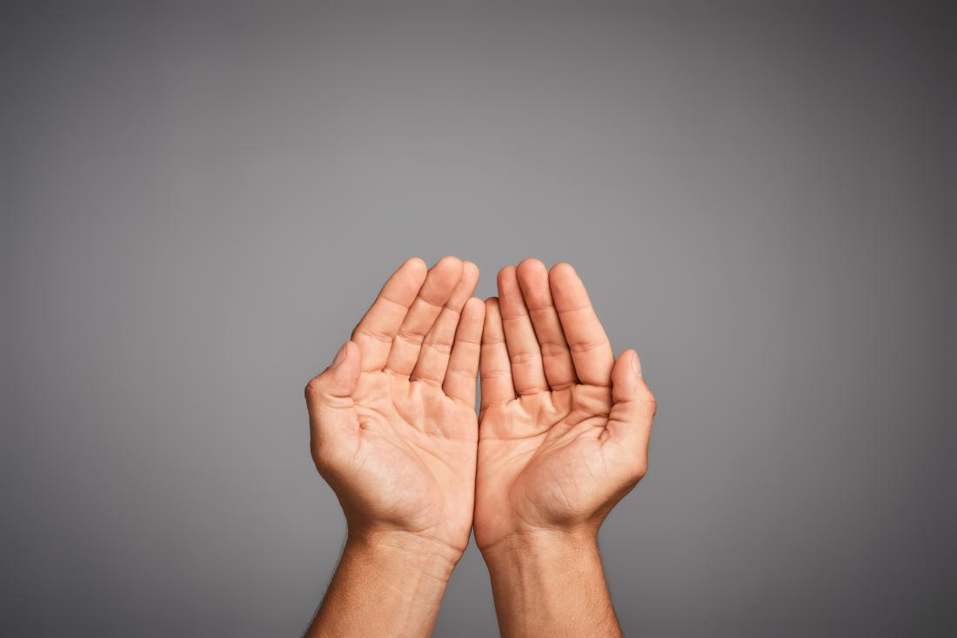

AFTER

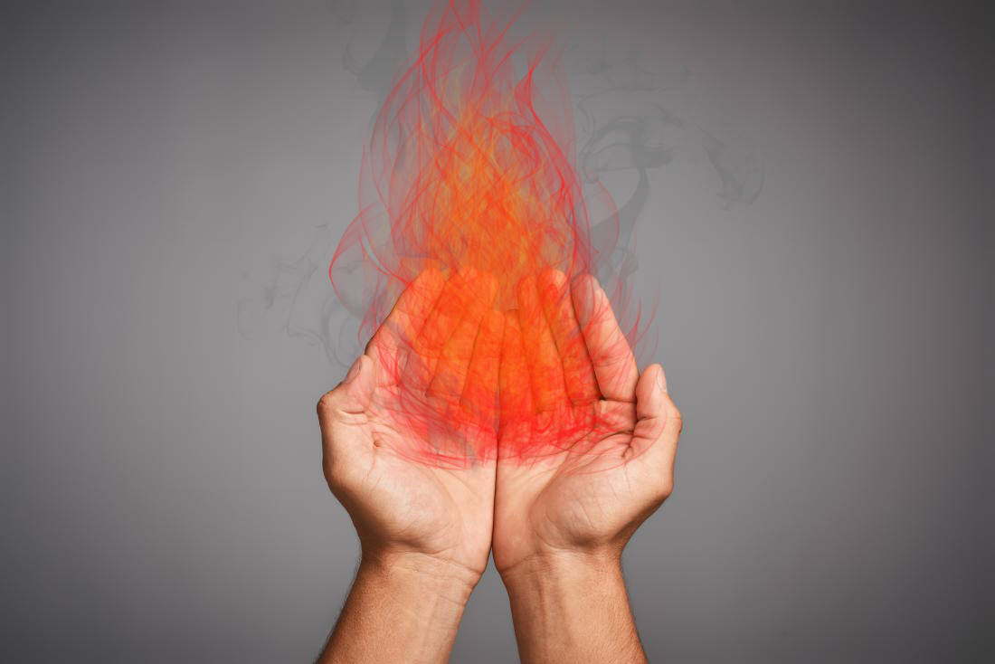

POINT OPERATION

BEFORE



AFTER

FILTERING

BEFORE

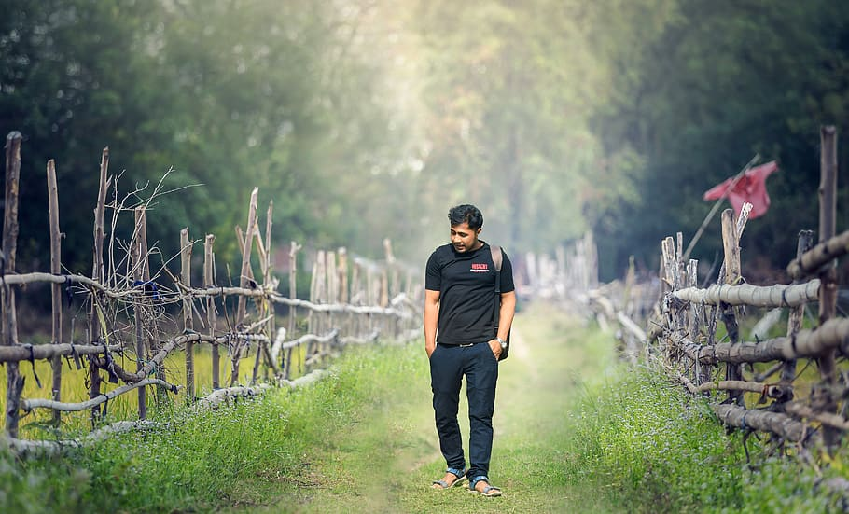

AFTER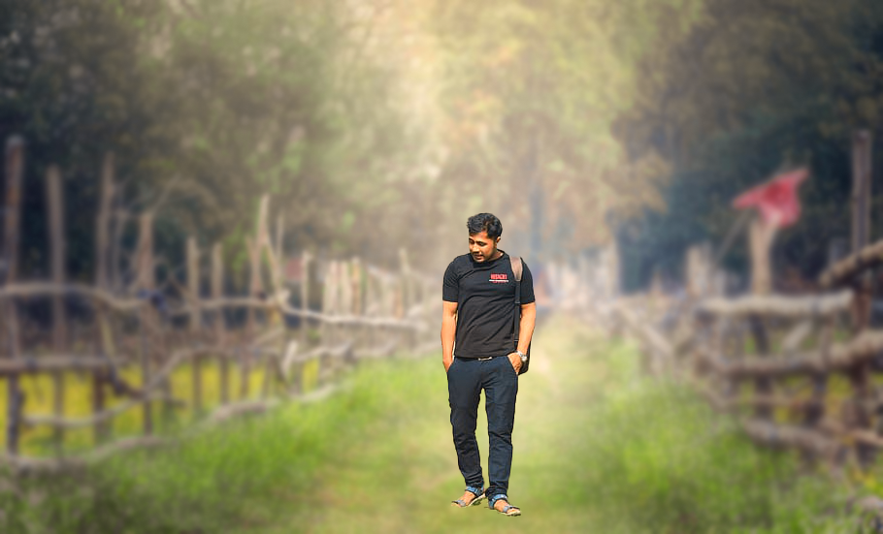

COMPOSITING

RAW COMPONENTS

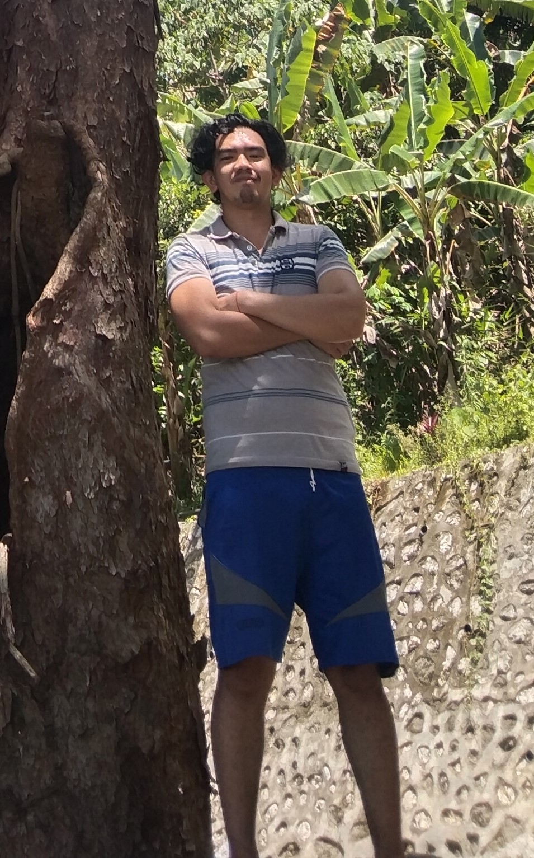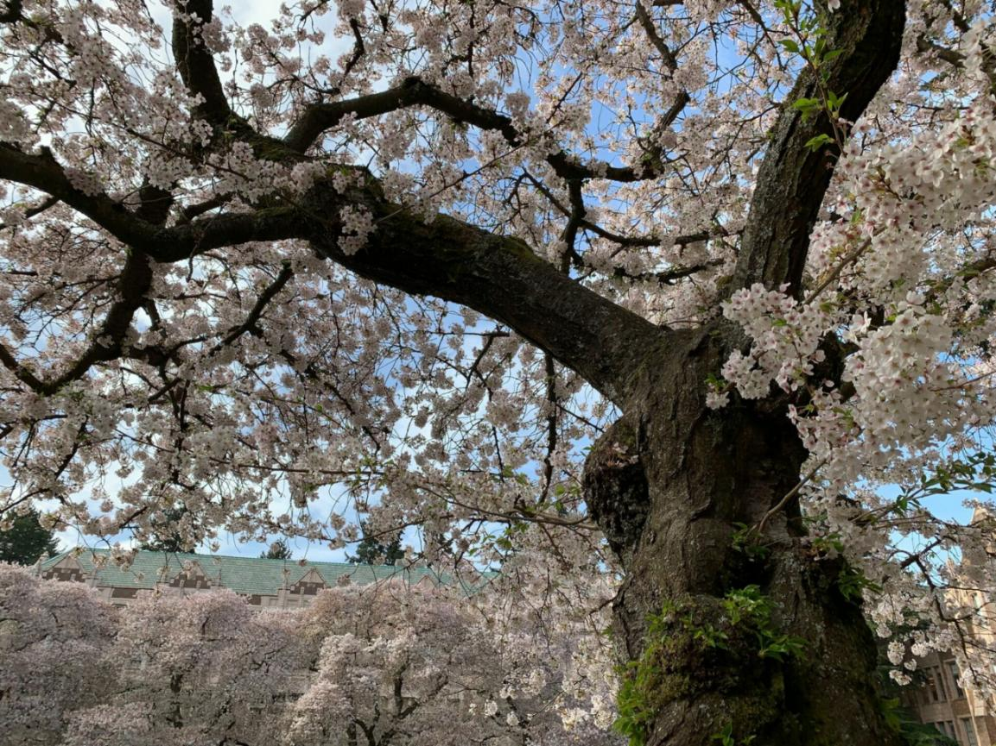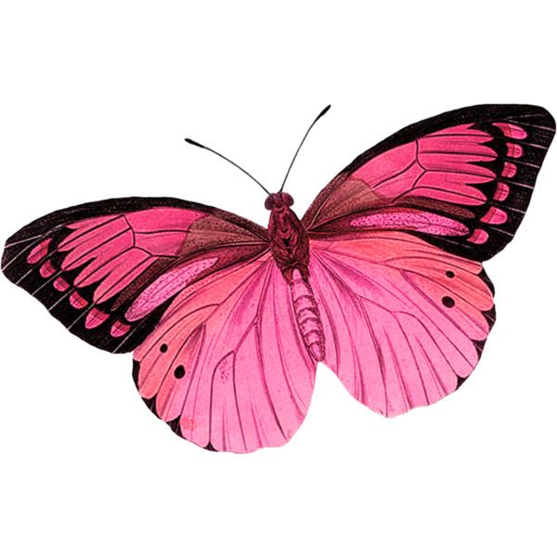

OUTPUT

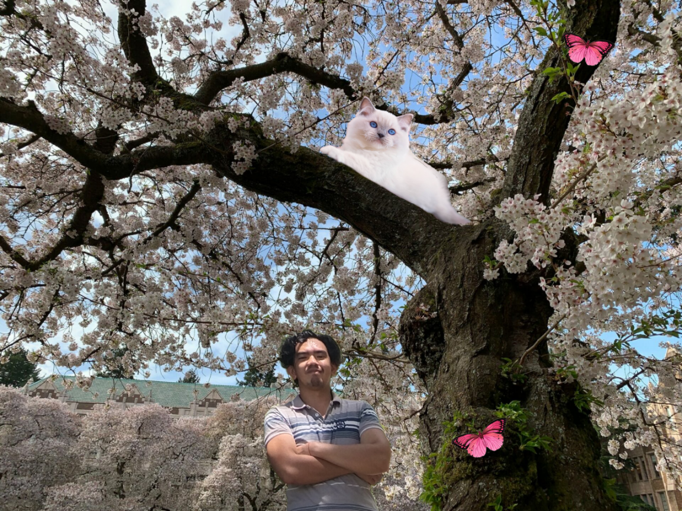

GEOMETRIC TRANSFORMATION

BEFORE

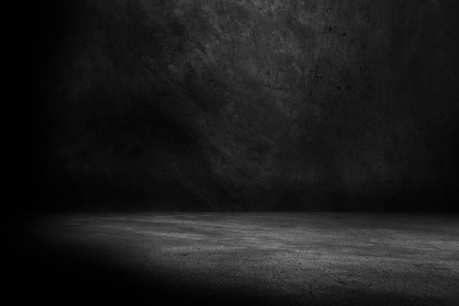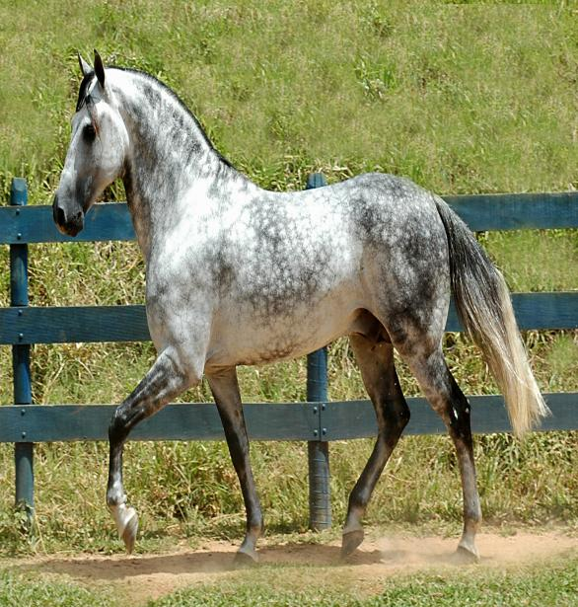

AFTER

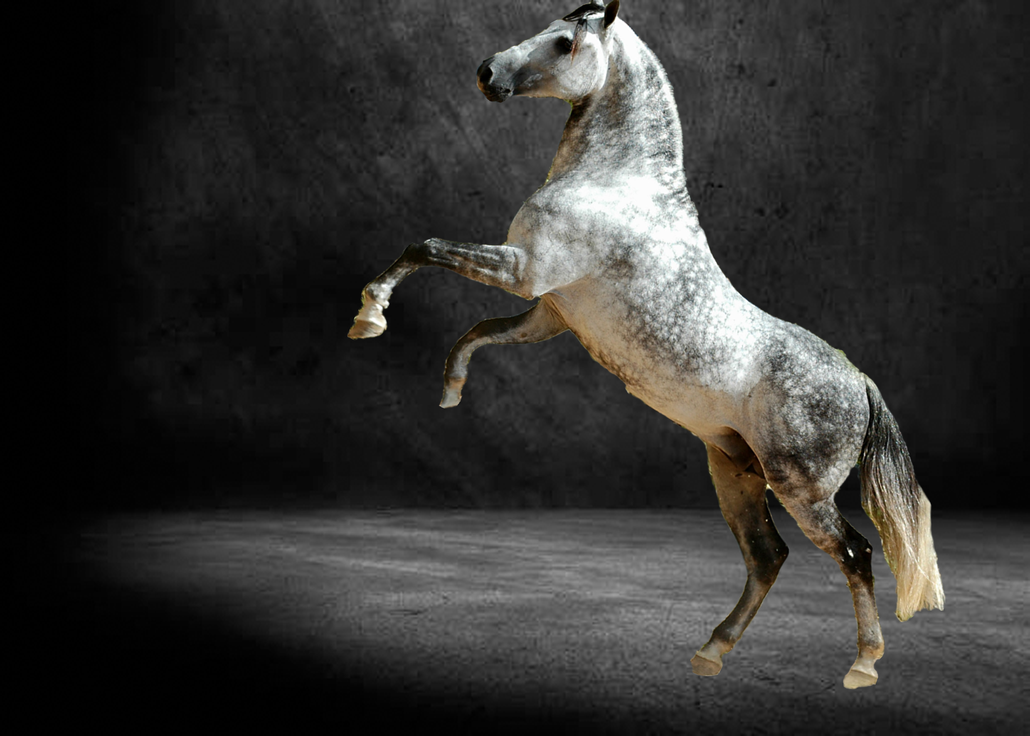

CONVERSION

Bmp:



I choose this as a BMP file because the format's uncompressed nature ensures that every pixel retains its original quality, crucial for preserving the intricate details in my black and white image. The lossless characteristic of BMP is essential for maintaining the highest fidelity in monochromatic compositions without sacrificing clarity.

Jpg



i choose this as a jpg file because JPG is commonly used for photographs and images with a broad range of colors and gradients.This format is ideal for efficiently storing and sharing black and white images without compromising on clarity, making it a versatile choice for a wide range of visual content.

Png



I choose this as a PNG file because, during filtering and editing, PNG proves to be ideal for preserving sharp contrast, edges, and transparent elements in web graphics. The format's lossless compression ensures that my black and white image retains its high quality, making PNG a suitable choice for intricate edits and maintaining visual precision.